Design an Inclusive Writers Workshop

AssisTechKnow

October 20, 2016

Susan Hardin

shardin@misd.net

@shardin22

http://inclusivewritersworkshop.weebly.com/

Writer's Workshop Resources
Teacher's First: Writer's Workshop  The basics of Writer's Workshop and lots of resources and ideas from k-6  http://www.teachersfirst.com/lessons/writers/index.cfm  Help Students Generate Ideas Through Prewriting Learn how to model a range of prewriting techniques and introduce several mnemonics to help students organize their writing.  Help Students Generate Ideas Through Pre-writingLearn how to model a range of prewriting techniques and introduce several mnemonics to help students organize their writing http://www.adlit.org/article/36070/#tech  Interactive Technology Literacy Curriculum:  This site contains resources that focus on the use of technology to promote emergent literacy with children, three to five years of age with disabilities.  http://www.wiu.edu/itlc/ws/ws1/litfound_4.php  Eliminating the Box: Generative Writing for Students with Significant Disabilities  Great blog post about emergent writers, alternate pencils and writer's workshop ideas for students with disabilities.  http://eliminatingthebox.blogspot.com/2013/07/generative-writing-for-students-with.html  Literacy for All  The purpose of this wiki is to provide information and resources for teachers who want to learn more about literacy instruction for students with significant disabilities and to model what an online community of practice for teachers could look like.  .http://abliteracyforall.wikispaces.com/Home | 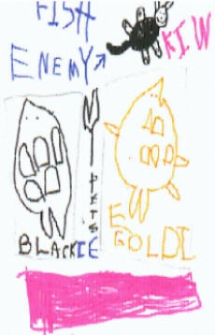

NCK12 Writing Continuum
http://attools.weebly.com/uploads/6/3/2/2/632284/nc_k-2_writing_continuum.pdf

Heidi Songs Developmental Profile
http://www.heidisongs.com/Free_Downloads/assets/Stages_Of_Childs_Writing.pdf

HIAT Spelling Analysis
http://www.montgomeryschoolsmd.org/departments/hiat/forms/WPP_spelling_howto.pdf

About Word Banks
http://www.theschoolrun.com/what-word-bank

The Basic Spelling Vocabulary List

By: Steven Graham, Karen R. Harris, and Connie Loynachan (2008)
https://www.dropbox.com/s/ydxhel59c9lozxk/850%20Words%20needed%20to%20write.pdf?dl=0

Dictation For Emergent Writers
http://thisreadingmama.com/dictation-with-young-children/?utm_source=themeasuredmom.com&utm_medium=referral&utm_campaign=pubexchange_article

Explore Emergent Writing Ideas:
https://www.pinterest.com/melstephens15/writing-workshop/

Erin Klein’s Writer’s Workshop Page on Pinterest
https://www.pinterest.com/erinklein/writing-workshop/

Mini Lesson Topics
https://writersworkshopk6.wikispaces.com/file/view/Topics+for+Mini+Lessons.pdf

Five Card Flikr Stories
http://5card.cogdogblog.com/play.php?suit=5card

Writing Tools

Low Tech: Pencil grips; Stamps; Whiteboards; Letter Cards

Planning Writing:

Kidspiration
http://www.inspiration.com/freetrial
Webspiration: http://www.inspiration.com/freetrial
Kidspiration Lite: http://www.inspiration.com/freetrial

Template Writing Emergent Writers
First Author | Clicker Sentences  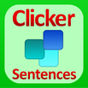 | Clicker Docs | Clicker 6

Writing with Voice Emergent Writers
Sock Puppets | Scribble My Story  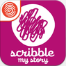 | Dragon Dictation | Voice Recognition App

Word Prediction and Revision
iRead Write | CoWriter Universal | Read&Write for Google | Natural Reader

Publishing Writing

Book Creator | PowerPoint | Tar Heel Reader  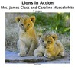 | Hiaku Deck

